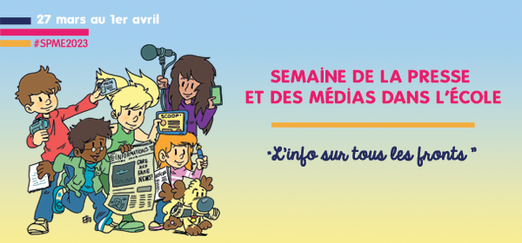

Des classes de primaire écrivent et dessinent l'Hebdo des petits citoyens

Comme chaque année, à l'occasion de la Semaine de la Presse et des Médias à l'École organisée par le CLEMI, Les petits citoyens invitent des classes de primaire à devenir des petits reporters en rédigeant notre journal d’opinion l’Hebdo pour une édition spéciale.
Les classes des écoles Charles Hermite et Jardinet à Paris et de l’école Jean-Paul Marat à Échirolles, ont ainsi rédigé les articles et réalisé les illustrations de notre journal paru en date du 27 mars autour de la thématique : « L’info sur tous les fronts ».
Un grand merci aux enseignants et petits reporters des écoles participantes !

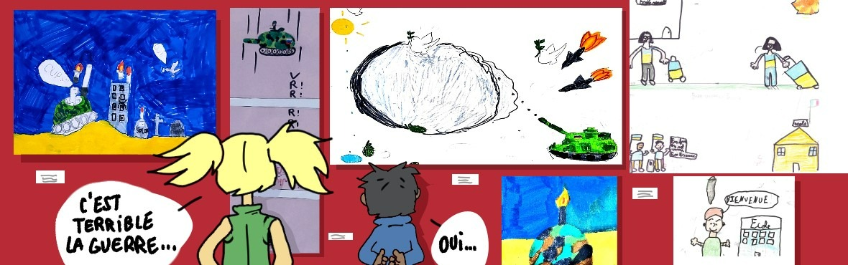

Découvrez l’hebdo

https://lespetitscitoyens.com/journal/

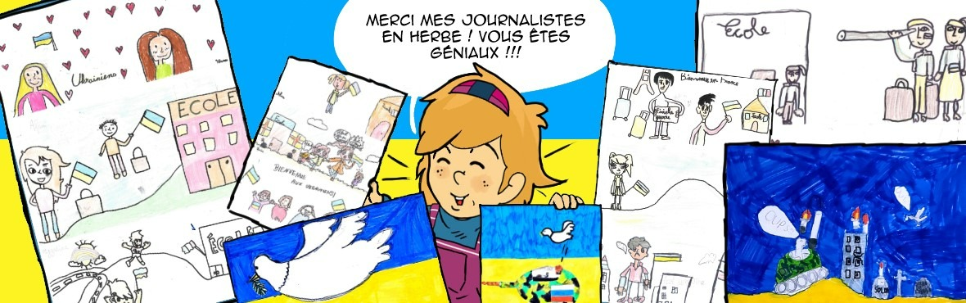

Découvrez les dessins des enfants

